ELECTRIC VEHICLE MARKET ANALYSIS

OBJECTIVE:
The goal of this project was to analyse the global adoption of electric vehicles (EVs) using Tableau. The analysis focused on understanding EV growth trends, performance by manufacturers and states, and the impact of vehicle type, model year, and price category on average range and adoption patterns.

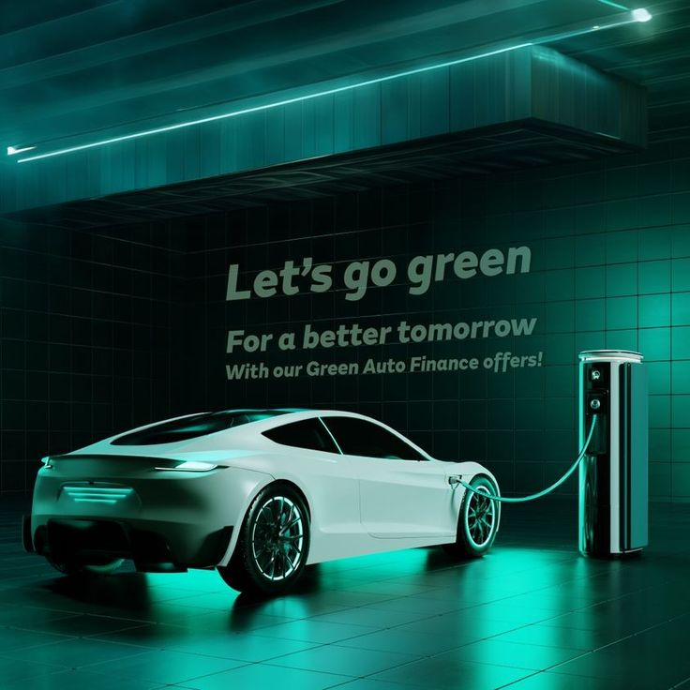

BUSINESS CONTEXT:
🔹Strategic Market Growth: The EV sector is expanding rapidly as part of the global push for carbon neutrality and sustainable transportation.
🚀 Data-Driven Decision Support: Analysing adoption and performance trends enables smarter investments, production strategies, and infrastructure development.
💼 Competitive & Innovation Insight: Understanding manufacturer dominance and regional trends helps stakeholders identify new growth opportunities and drive innovation.

DATASET:
Data set link : Electric Vehicle Population Data 2025
Key Columns include:
- Model Year
- Make (Manufacturer)
- Model
- Electric Vehicle Type (BEV, PHEV)
- Range (km)
- Electric Utility
- City
- State
- Postal Code
- Base MSRP (Price)

DASHBOARD OF EV MARKET ANALYSIS

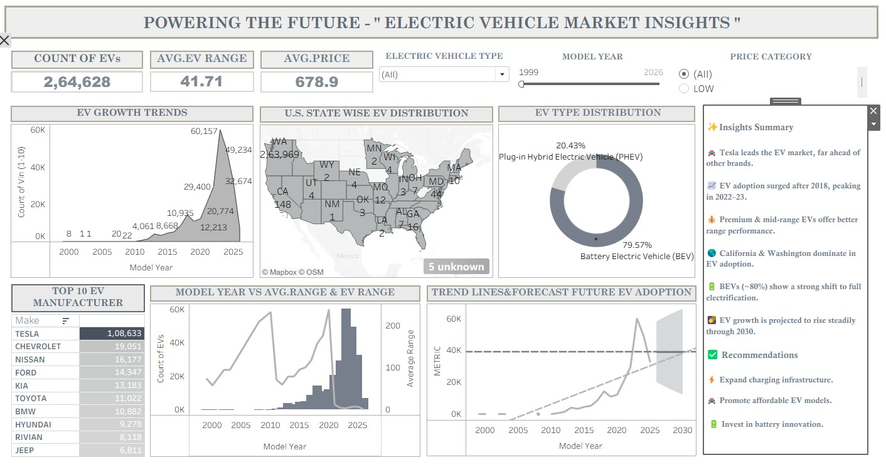

KEY INSIGHTS:

- 🚘 Tesla Dominance: Tesla leads the EV market with over 40% share (1,08,633 vehicles) — far ahead of Chevrolet, Nissan, and Ford.
- 📈 Adoption Surge: EV growth accelerated post-2015, peaking around 2022–2023, reflecting massive consumer adoption.
- 🔋 Full Electrification Trend: BEVs make up ~80% of all EVs, showing a strong shift away from plug-in hybrids.
- 💰 Balanced Market Demand: Mid-range & Premium EVs offer the best mix of cost and range, driving steady consumer preference.
- 🗺️Regional Leadership: Washington & California top EV adoption, highlighting strong policy support and green awareness.

RECOMMENDATIONS:

- 🔌Expand BEV Infrastructure: Increase investment in public and private charging networks in top-adopting regions.
- 🚗 Promote Mid-Range Models: Support production and financing of affordable EVs that maintain high efficiency.
- 🌱 Support New Entrants: Encourage innovation among emerging manufacturers to strengthen market diversity.
- 🏛️ Regional Incentives: Provide tax credits and subsidies in states with slower EV adoption to balance growth.
- 📊 Leverage Forecasting: Use trend analysis and predictive modelling to align production and policy with future EV demand.

